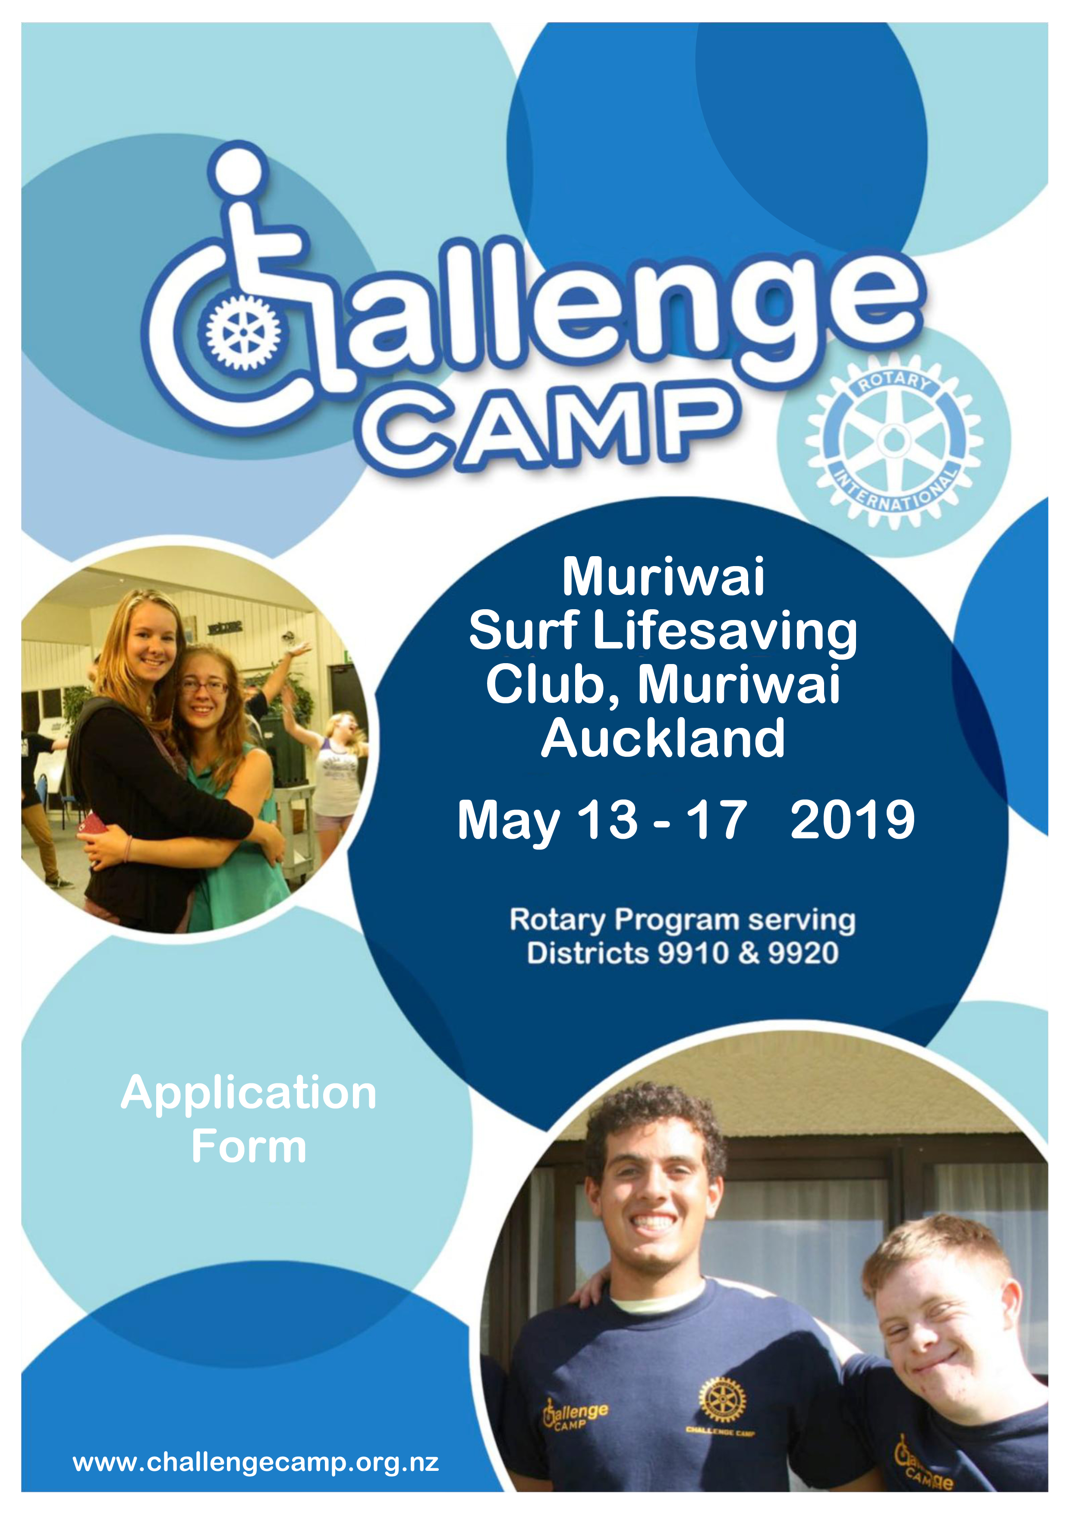

Part Two of this Application should be completed and signed by your Medical Practitioner – however you may prefer to complete the questionnaire yourself and have your GP sign it with any comments, which he/she may think necessary.

Please Describe your Physical or Intellectual Disability:

Physical Ability/Status and Special or Other Assistance required on a daily basis?

(Please describe fully – you may also wish to talk with your Rotary Contact Person with any concerns or questions before completing this part)

Mobility:

Describe mobility aids:

Communication:

Meals:

Toileting:

Showering:

Dressing:

Hearing impairment:

Sight Impairment:

Can you swim?:

Are you confident in deep water?:

Allergies:

Bee stings:

Anxiety Issues / Panic Attacks / Paranoia?

Other:
Medical concerns that could stop participation in activities (Back problems, water, height, open spaces, darkness – details:

Food / Dietary Needs: (Describe any special needs or food allergies)

Your Doctor’s name:

Phone: After hours:

Practice name;

Address:
I approve attendance at Challenge Camp 2019, Muriwai Surf Lifesaving Club and all other camp activities and the ability of the applicant to participate in all presented activities. In the event of an accident or illness, I authorise the organisers of Challenge Camp 2019 or their activity providers to obtain any such medical treatment or assistance as considered appropriate.

I agree that the organisers of Challenge Camp 2019 and/or any helpers and activity providers cannot accept legal liability for personal injury, illness, or death of any participant, or, loss or damage of any personal property through theft or accident or otherwise during Challenge Camp 2019.

Applicant: Sign

Print Name: Date: / /

Parent/Guardian: Sign

Print Name: Date: / /

Other Information

Please request your Doctor to describe fully your requirements for medication. (See Doctors Questionnaire)

Do you require medication? Yes No

Please ensure any required medication is detailed by your doctor so that we can assist you, please tell us anything else about yourself which you think we should know.
What to bring with you:

• Underwear for five days or more.

• Socks (5 pairs or more)

• Pyjamas and dressing gown.

• Footwear for indoors and for outdoors. Warm clothing Pullover or jacket.

• Hat, balaclava or other warm head wear, and sunglasses

• Raincoat / wet weather gear, umbrella.

• Sleeping bag and pillow

• Outdoor Clothing (for 5 days) suitable for outdoor / adventure activities.

• Clothing suitable Woodhill Tree Adventures and Swimming Pools visit.

• Swimming togs and two towels.

• Indoor Games, Reading material (books or magazines to read at quiet times.), Music CDs or instrument?

• Toilet gear (toothbrush and toothpaste, deodorant, shampoo, shaving gear, etc.).

• Medication. Sufficient supplies of any you use (or might need) to last for 5 days.

Valuables:

Please do not bring to camp any items of high value, e.g. jewelry, electronic equipment, cameras, etc. Should you choose to bring any equipment you are reminded that Henderson Rotary Club will not be responsible for any lost or damaged personal property. Participants should have insurance cover for their personal property.

Unauthorised Drugs or Alcohol:

No Unauthorised Drugs or Alcohol are permitted at the Challenge Camp. If unauthorised or banned drugs, alcohol or other substances are found in the possession of any individual, or on the premises or grounds of the Camp, the organisers and those responsible for Challenge Camp
2018 are authorised to carry out an investigation...
Part Two: Medical Assessment

Applicant’s Name:

This form may be completed by the applicant and signed by Doctor or Clinic Nurse

Medical History: Important Notes for Medical Examiner: Please CIRCLE Yes or No to the questions below and attach a detailed report to this application of issues and remedies to any Yes items. This will to help staff act ions in case of emergency.

Specific Disabilities: Has the applicant a history of any of the following: Involuntary fits, convulsions or spasms that might preclude the applicant from taking part in some activities?

A Rheumatic Fever YES NO B Chest Pain YES NO C High Blood Pressure YES NO D Depression, Anxiety, Anger, or Violence issues YES NO E Bed wetting or toiletry problems YES NO F Kidney or Bladder disease YES NO G Any Heart Condition YES NO H Diabetes YES NO
I Other serious illnesses YES NO J Other serious Operation YES NO K Skin Complaints YES NO L Drugs or Other Allergies YES NO M Regular use of drugs or Medication YES NO N Physical/Intellectual Limitations YES NO O Is the Applicant a Smoker? YES NO P Are Applicant’s tetanus injections up-to-date? YES NO Q Abnormal shortness of Breath YES NO R Asthma YES NO S Earache or ruptured eardrum YES NO T Fainting or blackout YES NO U Migraine YES NO V Sight or Hearing Impediment YES NO

Please attach to this application the following reports.

1. Medical History:

2. Specific Disability History:

3. Medication (include any specific instructions)

I have checked all Specific Disabilities items listed above and attached reports 1, 2 and 3 as required.

Doctor:

Sign: Phone:

OR

Practice Nurse:

Sign: Phone:

Practice name;

Address:

Thank you for completing this Medical Assessment – it will assist us in providing a safe and healthy camp for our participants.

Remember:

Initial Applications: Will close on Monday April 1st 2019. You need to fill in just Part 1 of the application form. We will assess your application and come back to you to complete Part 2 (this form)

Email your completed application or medical assessment form to: info@challengecamp.org.nz

Mail replies to:

Rotary Club of Henderson
PO Box 21038
Henderson
Auckland
0650

