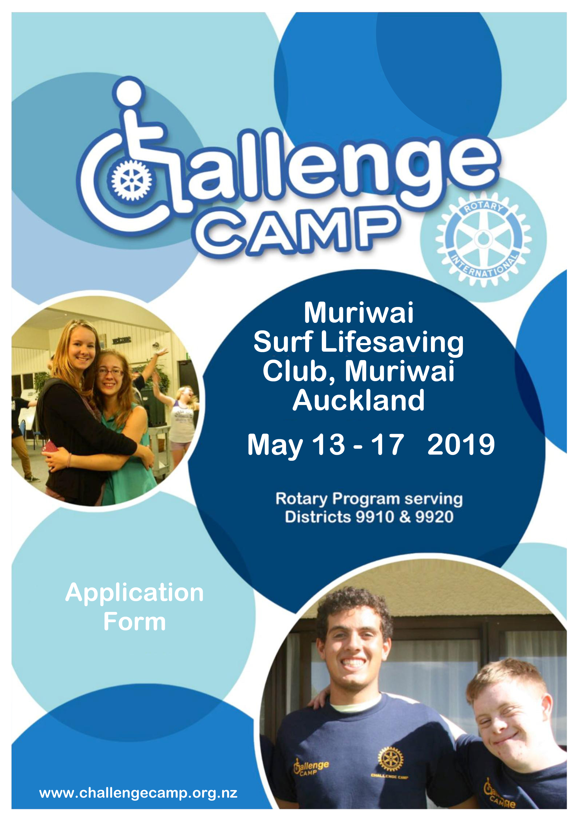
Purpose

The purpose of the camp is to provide an environment that will physically, intellectually and emotionally challenge young people who may not otherwise have the opportunity to attend such a camp.

Personal development and interaction of youth who experience special needs with the support of
Rotary International Youth Exchange Student mentors.

Programme

Challenge Camp 2019 is organised by the Rotary Club of Henderson for Rotary districts 9910 &
9920. It will run from 10.30 am Monday 13th May to noon on Friday 17th May 2019. The Location is Muriwai Surf Lifesaving Club.

What is provided?

All meals, accommodation, trips, activities, guidance and leadership by Resident Camp Mum and Dad & Rotary volunteers. Some activities will be under the guidance of Tree Adventures Woodhill Staff.
Note that costs for all of the above are covered by the Challenge Camp organisers through the support of Rotary Clubs all across the Auckland and Northland Region. There is no cost for attendance at the camp to you.

Applications

Applications will close on Monday

This is necessary to allow time for assessment and final confirmation of accommodation and activities.

Organised activities include:

Professionally supervised participation in:
Tree and ropes course at Tree Adventures, Woodhill
Parakai Hot Water Pools
Introduction to Circus session from Circability
Motivational speakers and visiting celebrities.
Social activities such as, Concerts, visits to exciting locations, etc.

Qualifications
The basic qualifying criteria for selection of campers are:

• Age: 16 to 24 years.
• Candidates must reside within Rotary Districts 9910 or 9920 and must not have been on a previous Challenge Camp.
• Applicants must have a physical and /or intellectual impairment. Such as: Spinal injuries (wheelchair bound), loss of lower limbs, birth defects (such as cerebral palsy and spina bifida), or have speech, hearing or vision defects.

Excluded are:
This camp is for youth who have a physical disability and /or intellectual impairment. Unfortunately this camp is not suitable for people with higher support needs e.g. people with intellectual disabilities which need experienced caregivers and those who are incontinent, wet beds, or require regular toileting assistance.

Disabled participants must be self sufficient enough that the partnered students (remembering that they are only of senior school age, are living away from home and for some of them English is a second language) don’t have to do anything too intimate to look after campers.
Application.

Applicants Full Name:

Gender Date of Birth: / /

Address:

Phone No:

Mobile:

Email Address:

Parent/Guardian able to authorise camper participation:

Full Name:

Gender

Address:

Phone No:

Mobile:

Email Address:
Emergency Contact Details (if different to above):

Full Name:

Relationship:

Phone No:

Mobile:

Referring Agency / School:

Agency Contact Person:

Phone No:

Mobile:

Email Address:

Sponsoring Rotary Club:

Club Name:

Rotarian Contact Person:

Phone No:

Mobile:

Email Address:

CRITERIA ACKNOWLEDGEMENT: I understand and acknowledge the basic qualifying criteria for selection of candidates (campers) and confirm that the applicant meets all the criteria. Non- compliance with the basic criteria may result in the candidate being sent home with any damages or costs being met by the camper, parents, or club.

Authorising Signatures

Applicant: Sign

Print Name: Date: / /

Parent/Guardian: Sign

Print Name: Date: / /

Agency/Rotary Contact: Sign

Print Name: Date: / /

Camper Qualifying Guidelines for Challenge Camp:

Self-Hygiene and Self-Care. Campers must be independently capable of and be fully responsible for their own hygiene, health and safety, and self-care. It is totally unacceptable to expect an untrained 17
or 18-year-old buddy (international exchange student) to be asked to handle any of these functions for a c a m p e r w i t h a d i s a b i l i t y .
Campers must be fully self reliant and independent in all toileting, showering, hygiene, dressing, and undressing functions. That means: Not needing the support of any care giver in any function of an intimate or sensitive nature.
The only way this rule will be modified would be for very mild cases where a student buddy has agreed to the care requirements before the camp.

If any camper arriving at the camp does not meet the self-reliance requirement he/she will be sent home.

Campers should have reasonable social skills and should be capable of holding ongoing conversations with fellow campers and students and be capable of forming and enjoying ongoing communications and friendships or relationships. This is a vital part of the camp for both campers and students. Campers who have anxiety issues or will have severe difficulty in being in an unfamiliar environment and meeting a large number of new people may be unsuitable for Challenge Camp – if there is any possibility of issues of this nature, please note them and discuss them with us.
Anti-social behavior, anger problems, and/or violent behavior will not be tolerated.

We stress that communication, self-care and hygiene, social skills, self-direction, health and safety, are all important skills for ensuring that both campers and their student buddies have a great camp experience.

I confirm applicant qualifies under self-hygiene and self care guidelines. If applicant does not meet guidelines please describe additional issues or disabilities in detail:

Rotarian Contact: Initial: _____

Parent/Guardian: Initial: _____

Agency: Initial: _____
Other Disabilities:

Vision Impairment:

Applicants with serious vision impairment or blindness should have full or near full other physical abilities, enabling them to participate fully in camp activities and challenges.

Hearing Impairment:

Applicants with serious or total hearing loss should preferably have full or near full other physical abilities, enabling them to participate fully in camp activities and challenges.

Applicants using a wheelchair:

To maximise the value of the camp we prefer applicants to have good functional strength with minimal limitations or control problems in arms, shoulders, or trunk. Applicants must be able to show good balance and therefore are very stable in a wheelchair without support or strapping. That is, move their trunk in an upward direction, can rotate, can move backward and forward, and preferably can move side to side.

We expect campers to have sufficient arm and shoulder strength to be independently mobile in propelling their wheelchairs (no electric wheelchairs). Therefore applicants would only need assistance in difficult environments like climbing a long hill or on a beach or getting their wheelchair into a vehicle.

We expect wheelchair campers to become self reliant in; archery, kayaking, snorkeling, swimming and climbing (with support).

The more common conditions affecting eligible applicants will usually include: traumatic paraplegia, spina bifida, lower limb amputees, and cerebral palsy.

To help applicants assess application criteria we have listed some sports’ gradings that may help some applicants understand the minimum qualifying guidelines:

Cerebral Palsy:

Athletics grading “CP4” where the athletes show good functional strength with minimal limitations or control problems in arms and trunk. The athletes show poor balance. The athletes compete in wheelchairs. “CP5” Athletes have normal static balance, but show problems in dynamic balance. A slight shift of center of gravity may lead to loss of balance. The athletes may need an assistance device for walking, but not necessarily when standing or throwing (in athletics field events). The athletes may have sufficient function to run on the track.

I confirm applicant meets the wheelchair disability guidelines if applicable. If applicant does not meet guidelines please describe additional issues or disabilities in detail:

Rotarian Contact: Initial: _____

Parent/Guardian: Initial: _____

Agency: Initial: _____
Involuntary Movements:

Campers who show involuntary cyclic movements should be able to walk without any assistance and be capable of participating in activities like archery, climbing (tethered and if needed supported of course), snorkeling, and kayaking. Applicants with insufficient balance or strength would most likely not qualify for the camp
I confirm applicant meets the Involuntary Movement guidelines if applicable. If applicant does not meet guidelines please describe additional issues or disabilities in detail:

Rotarian Contact: Initial: _____

Parent/Guardian: Initial: _____

Agency: Initial: _____

Flexibility in Guidelines:

There are situations where an applicant does not fit into the exact guidelines for acceptance. In these cases, we are happy to have the camper assessed and make judgments that accommodate the applicant, providing we are given accurate information enabling us to understand how we might cope with special needs. If there are any other special needs we should know about that are not covered on the attached Medical & Disability & Waiver of Liability form please let us know here:
Medical & Disability & Waiver of Liability Information

The candidate will be also required to fill out a more detailed application form (attached) and have it signed by their GP.

The accuracy of this is critical in matching the candidates and in regard to medical, dietary and safety issues.

The rules for the camp are that no Unauthorised Drugs or Alcohol is permitted at the camp. Failure to comply with these rules will result in the candidate being sent home.

Please answer all questions with attention to detail. It is important that you describe your disability or special needs in full so that we can make arrangements to accommodate these and make your stay an enjoyable one for you and the exchange students an occasion to remember.

Thank you for completing Part One of this application form.
We will assess your application and advise when you need to complete Part Two (the medical assessment).

Please send your completed application form to: Email:
info@challengecamp.org.nz
OR
Post:

Rotary Club of Henderson
PO Box 21038
Henderson
Auckland
0650

Important Reminder

Applications: Will close on Monday April 1st, 2019

